Table Of Contents

Chapter One: Introduction 3

1.1 Introduction to the project 3

**1.2** Background of the study 4

**1.3** Statement of the problem 5

1.4 Aims of the study 5

**1.5** Objectives of the study 5

**1.6** Scope of the study 5

**1.7** Significance of the study 6

Chapter Two: Literature Survey 7

2.1 Literature review 7

2.1 Existing research and related pharmacy e-commerce 7

Chapter Three: Software Specifications 10

3.1 Software Development 10

3.2 System Requirements 11

3.2.1 Functional Requirements 11

3.2.2 Non-Functional Requirements 12

3.2.3 Software and Hardware Requirements 13

3.2.4 User Interface Requirement 14

3.2.5 Test Plan 15

Chapter Four: Design 16

4.0 System design 16

4.1 Flow chart of the propose Web App. 16

4.2 Use Case Diagram 18

4.3 Block Diagram 19

4.4 Sequence Diagram 20

4.5 Architectural Context Diagram (ACD) 20

4.6 System Architecture 21

4.7 Entity Relationship Diagram 23

4.8 Wireframe Design 24

Chapter Five: Implementation 25

5.1 Source code 25

Chapter 6: Testing 30

6.1 Software Testing 30

6.2 Testing Plan 30

6.3 Important Checklist 31

6.4 Error and Success Functionality test 32

Chapter Seven: Demonstration 33

7.1 Activity Flow Diagram 33

7.2 Activity Flow Screen 34

7.2.1 Home Screen 34

7.2.2 Login / Register Screen 34

7.2.3 Cart Review Window 35

7.2.4 Check Out Screen 36

7.2.5 Wish List Cart 37

7.2.6 Product Preview Screen 38

7.2.7 User Profile Dashboard 38

7.2.8 Order Management Window 39

7.2.9 Admin Management Dashboard 40

7.2.10 Consultation / Messenger Window 42

7.2.11 About APP 42

Chapter Eight: Conclusion and Recommendation 44

8.1 Conclusion 44

8.2 Recommendations 44

Chapter Nine: Appendix 45

9.1 Quick Start Guide 45

9.2 Test Case Result 46

9.3 Project Meeting Logs 47

9.4 Timeline (Gantt chart) 48

References 49

# Chapter One: Introduction

## Introduction to the project

The progressive and recent success in technology have played a major role in evolving the health sectors, as most medical practitioners are now key into the idea of computational practices over conventional processes, Also Pharmaceutical practices have evolved over time from its conventional practices to using computational methods in all aspects of pharmaceutical process. which include: dispensing of drugs, consultation, drug regulation, and the sale of these drugs. The birth of modern pharmacy has brought with it some positive effects in the society as pharmaceutical practices have grown beyond conventional buying and selling of drugs over time, to more robust activities which include inventory of stocks, transaction tracking, door to door services and the general implementation of medical orders which entails the evaluation and the interpretation of the medical orders, the administration of drugs, dispensation of prescribed drugs from qualified medical practitioners, the review of prescribed drug regimen, invention of methods and devices to accurately dispense drugs and the correct storage of drugs.

The modern pharmacy is an extension of the service available to patients by medical providers, such as general practitioners (GPs) and hospitals. It is the main distribution channel for pharmaceutical products and thus plays an important role in the health care system of a country, most of times patients may feel lethargic to visit the medical shop at the time of medicines needed. This leads to improper body conditions that makes them suffer lot which may cause late recovery from the disease/illness. So, it is necessary to take proper medicines in proper quantity at proper time. In nearly all cases these medicines are available to the patient via a pharmacy. Although very little has changed with regards to the distribution of medicine, Pharmacies are now seeking to improve their competitive advantage by developing their direct relationship with the end patient using enhanced product service delivery via efficient and effective supply chain management by providing a platform for patients to have easy access to professional consultants and in buying medicine.

The proposed system aims to automate pharmaceutical practices and serve as an intermediary between pharmacies and general public, through a platform that allows the order of drugs with the click of a button, and simultaneously keeps track of what drugs have been ordered and in what quantity (inventory), provide online platform for buying of medicine and also create avenue for a one-on-one interaction between pharmacist and the general public.

## **1.2** Background of the study

Access to medication has been a topic of discuss over the years, many solutions has been proffered in the past to provide easy access to medication and professional consultation from pharmacist for users at any time of needs. The challenges for users to access pharmaceutical stores has been discuss to be among the main causes of lack of access to medications by users. Most times, people can only access the medicine available in the pharmaceutical stores withing their vicinities which at most times have little or no provision to quality medicines and as well a collection of variant medication for different illness.

Also, the lack of access to professional pharmacist for consultation is one of the major causes of recent rapid growth in self-medication among people, in the quest for treatment and desire to quickly recover from any sickness people listen and accept advice from other people who are neither a professional in the field of medicine nor a train pharmaceutical practitioner. This people offer this advice base on their experience from medicine they’ve used in the past which possibly must have help them to recover from their sickness.

The proposed pharmaceutical management system will provide a real time platform for general public or registered users to seek for professional counselling from professional pharmacist where they can discuss their health concerns on a one-on-one interaction and at the end get a drug prescription of which they can then proceed to search and order from the online stores. the users can also choose the drugs be delivered to their homes or anywhere suggested. The system will provide a platform for user’s education on medical health from reading articles written by professional pharmacist on the platform. The system will also provide inventory functionalities for the pharmaceutical stores. The system will also provide platform to register new users and pharmacist and another platform for administrative users to manage every type of users that uses the system.

## **1.3** Statement of the problem

The existing system is face with several challenges which includes:

* Lack of real-time access to professional pharmacist for consultation.
* Lack of access to any type of medicine at anytime and anywhere.
* Lack of delivery of medicine from anywhere to patient in any places.
* The current manual process is not User-Friendly and ease of use.

## 1.4 Aims of the study

The aim of the project is to development a web base application that provide users with functionalities to order and pay for medicine online or after delivery to their home or any places of their choices and to also provides access to professional pharmacist for consultation.

At the end we aim to provide a well-tested and fully functional system that handles all pharmaceutical process from consultation services to buying and selling of medicines and taking inventories.

## Objectives of the study

* To create online web base system that fully automate pharmaceutical practices
* To provide a system that can present efficient information about medicine.
* To provide a system for buying medicine online.
* To develop a system that provide a platform for public users to interact with professional pharmacist at anywhere and anytime.
* To create an inventory platform for pharmaceutical stores.
* To create a platform for professional pharmacist to write and publish health related articles
* To reduce effort and frustration face by people in buying medicine and getting consultation from professional pharmacist.

## Scope of the study

This project is developed to provide a functional web application to manage and handle a pharmaceutical process and to improve the quality of services offered by pharmaceutical stores.

## Significance of the study

The system will address many of the pitfalls in a conventional way of running pharmaceutical business, which include:

1. The bottleneck in buying and selling of drugs

2. Lack of access to medical health education.

3. Abuse of drug.

4. Lack of proper professional medical prescription.

5. Self-treatment and medication.

6. Lack of transaction history and stock inventory for pharmaceutical stores.

7. Lack of adequate and accurate medication or treatment history of individuals.

# Chapter Two: Literature Survey

## 2.1 Literature review

In this chapter, we will provide a theoretical background that will act as a framework and a foundation for our study. This framework is built upon a consolidation of knowledge from two different fields; review of previous research on mobile application development and studies of previously developed tourist systems. By reviewing research of already developed tourist systems we aim to collect and analyze a set of functionalities that these projects implemented.

## 2.1 Existing research and related pharmacy e-commerce

There are many applications that are similar to the electronic commerce for pharmacies. These applications are working to facilitate the process of getting a medical product through the use of the website, e-pharmacies are divided into several types, including the hospital pharmacies and health institutions or independent electronic pharmacy. For example, there are many similar applications to the electronic pharmacy in the Arab and the Western world, such as electronic pharmacy system in Dubai hospitals, Adama pharmacy, Fouda Pharmacy and dowa Kuwait online pharmacy among others. All these websites contain several sections of products, including Hair care, skin care, mother and baby, Medicine Cabinet and many others.

EC allows the creation of new business models such as e-tailing (online selling). (Turban et al. 2012).

The 20th century thus saw the proliferation of e-pharmacies (selling medication over the internet). Globally, e-pharmacies is a US$ billion industry and is forecasted to be about US$51.75 billion by 2030. The US, Europe, and Canada holds the largest market share with the US representing the largest regional market with nearly 50%, and Europe representing the second largest and fastest growing market, growing at a rate of more than 20% annually. ('Global ePharmacies Market' 2011)

The Canadian e-pharmacy industry has grown to US$1billion in sales with over 100 Canadian e-pharmacies. (Farrell and Fearon 2005).

E-pharmacy is an Australian online pharmacy (with a physical store in Calamvale) that was launched in the year 2000. The pharmacy industry in Australia is worth over AUS$10 billion yearly. E-pharmacy experienced sales increase of over 20% monthly since its inception. In one year, the site sold over AUS$500,000 worth of products. E-pharmacy experienced such extensive and rapid growth within Australia that they planned to open a megastore to sell directly to the public and to serve as a warehouse. (Lane & Koronios 2017)

Online Pharmacies associated with a conventional store, were found to be more successful than virtual pharmacies. (Cottrill 2000; Mahesh & Landry 2013; ‘Global ePharmacies Market’ 2011)

In Europe, EC in healthcare began in 1998, but took off in 2004. Denmark, Germany, the Netherlands, Norway, Sweden, Switzerland and the United Kingdom allow prescription-only medication to be dispensed by e-pharmacies. (Dudley 2012)

Alliance Boots, UK, is ahead of the other European pharmacies in its level of online services integrated into its pharmacies especially with its very successful order-online-collect in-store promotions. (Dudley 2012).

In Poland, Doz.pl is said to be the largest online Pharmacy and information site with almost 3 million users placing 100,000 orders monthly in 2011, (Dudley 2012) and since 2004, Internet pharmacies have been licensed to operate in Germany. ‘Pureplay’ pharmacies represent 3.5% of the total pharmacy sales. (Dudley 2012)

The UAE in general is working on the establishment of electronic pharmacies in all the Emirates with medications delivery service to the home. The doctor is also working on a review of medications and the duration of its validity and the quantities consumed largely of products to be provided quickly before stocks last (fouda.com. 2020).

Dubai Health Authority (DHA) applied electronic pharmacy system in Hatta Hospital, which aims to speed up the disbursement of medicines for patients by safety process. It facilitates many processes such as patient record, review as well as providing accuracy in the process of therapeutic description.

Adama pharmacy located in Saudi Arabia system able to develop a new concept in the area of customer service. In addition, it becomes a pioneer in this domain. So far, everyone commends the high-class level service provided. It includes several sections such as Mother& Baby, Skin care, Hair care, and other. Each section contains several products. This pharmacy is characterized by multiple sections and were carrying a large number of products and medicines. The instruction of how to use this website is straightforward by choosing the appropriate language to facilitate the selecting a product or medication. Then, the patient can log in to the site and select the product from the offered list. Or could use the search tool to choose the product and determines the quantity and enter the place of delivery, and paid using the credit card number (Adama pharmacy 2016).

Fouda Pharmacy is the First Electronic Interactive Pharmacy in Egypt. This website requires the customer registration as the first step to enter a user name and Password. Then you can use this site to choose a medical product that you want to, after that selecting the product is inserted into the customer data and the card number then sets address. This pharmacy provides medicines only and it does not provide medical or health products (Skin Care - hair Care - mother and baby products) like most of the e-pharmacies. It has a large number of categories and each category have huge number of medicines (Dowa Kuwait Online Pharmacy 2016).

Dowa Kuwait Online Pharmacy is an integrated service providing customers with pharmaceutical and healthcare products without the need to go to the pharmacy. It is the first online, high quality pharmaceutical service in the Middle East. It provides valuable online healthcare information in addition to specialized delivery services. In this website, simply place your order online through Dowa and it will have delivered to your doorstep wherever you are. To register in this website, you need an e-mail and password. This web site contains online doctor, Special Offers, multiple Categories, Brands and Products. The process of choosing a product or the medicine similar to what happens in the website of Fouda pharmacy (Dowa Kuwait Online Pharmacy 2016).

Each web-based application has specific features that make it the first over other websites regarding saving time and effort.

In conclusion, the many reviewed literature here has provided deeper understanding of the proposed application. Different scholars have written about the enormous advantage of integrating an e-commerce platform into pharmaceutical processes. Review of the related applications will help the researcher come up with an application that will eliminate some of the weaknesses in the related applications and also pick ideas from the strengths of those application to serve as guide in designing an improved application.

# Chapter Three: Software Specifications

## 3.1 Software Development

The proposed Pharmacy E-Commerce website will enable the patient to do several things such as immediate contact with a specific pharmacy to request their medicine securely and fast. Moreover, the orders can be delivered to patient locations with fewer fees, which will save efforts, money and time. In addition, patient can use the pharmacy's website to buy any medicine, medical materials, baby and mother care. With Electronic Pharmacy, waiting and standing in queues to receive medicine from the pharmacy it will become thing from the past because the electronic pharmacy will have shortened the time and the system will also provide users access to recognize and professional pharmacist for consultation. In addition, it will bring comfort for patient. It’s user friendly, and its aim to help user for accessing the pharmacy easily.

3.1.2 Benefit of the proposed system

1. The application is useful for users in buying medicine.
2. The application is useful for users that want have easy access to health information and consulting professional pharmacist.
3. The application automates the inventory process of a pharmaceutical store.
4. With the delivery options, the possibility of providing medicine to users at any location is possible and this will save efforts, money and time.
5. The application will eliminate the issues drug abuse, since users’ orders can be track.
6. The application will also eliminate the abuse by pharmaceutical store attendance in hoarding medicine and thereby increasing the cost of buying the medicine.

## 3.2 System Requirements

## 3.2.1 Functional Requirements

The software shall allow the different users (Pharmacist/Consultant, Buyers) to carry out the following functional operations:

All users:

1. Register on the app providing their email, name, phone and password
2. Login with their email and password
3. View different medicines either by categories or price range.
4. Navigate / browse through the available medicines
5. Chat or consult professional pharmacist online.
6. Add/Save medicine to Wishlist, in order to purchase later.
7. Buying or ordering of medicine online.
8. Paying for order either with card, cash or on delivery.
9. Manage his/her orders.
10. User should be able to view and update their profile information.
11. User should be able to add as many contact/delivery address to their account.
12. User should be able to logout of the app

Pharmacist/Consultant:

1. Provide real time and professional medical advice to users.
2. Check out user’s prescription and provide a professional guide for the user.

Admin:

1. Add new products (medicine) to the inventory.
2. Update the information of existing products (medicine) in the store.
3. Deleting/Removing a product from store.
4. Creating the difference product(medicine) categories.
5. Update users’ roles.
6. The app should provide a search features to enable users search for medicines either by name, descriptions or categories.

## 3.2.2 Non-Functional Requirements

1. **Usability**: The app comes with few screens and few menu options which gives users a simple and easy learning curve, the UI Design is design to make access simple and yet give users the best of experience.
2. **Security**: The system is secured as users are expected to register and login with their login credentials which comprises of email and password, user’s password is encrypted and stored in the system. this is done to protect the data for any case of data breach.
3. **Capacity**: The storage capacity of the system is at minimum of 1GB since there’s need to store files(images) of users and registered products(medicines).
4. **Compatibility**: The app is design to work fine any computer system with 1.8 GHz or faster processor with a minimum of 2gb RAM and external/internal storage capacity of at least 1GB, Internet access (4G) preferable and web browser application.
5. **Availability:** The app can be use anytime as long as the app compatibly is meet. In case of hardware failure or data base corruption a page replacement will be shown.
6. **Portability**: Our website is based on HTML and scripting language depended. The aim is to website application must work on PC, laptop and user-friendly devices.
7. **Maintainability**: The commercial database is applied for maintaining the all database also the application developer is updated time to time.
8. **Reliability**: As the data is stored on server site it is available to user and developer to read the information about disease, medicine. Database is available to read 24/7 for the user in convenient manner.
9. **Adaptive Design**: Our websites are designed to offer an optimal mobile experience. Our sites are able to determine the type of device in use and serve content optimized for that device. Specifically, we offer images with optimal file sizes – resulting in faster loading, more usable websites
10. **Platform independence:** The main aim of the site is to provide no platform barriers. This website can be compatible with all devices for mobile, laptops and tab.

## Software and Hardware Requirements

The hardware and software requirements needed for the successful running and implementation of the proposed system are computer system (laptops, desktops, phones, iPad etc). Most of the equipment requires less power and is mostly found among users. These requirements include:

3.3.2.1 Software Requirements:

* Windows 7/8/10 (32 or 64-bit operating system) and any other mobile operating system, RAM: 4 Gigabyte recommended;
* This application is written in JavaScript, and run in a web application therefore making it easier to be used in any platform and access in any location at any time.
* Web browser application: A web browser, often referred to simply as a browser, is application software for accessing the World Wide Web. When a user requests a web page from a particular website, the web browser retrieves the necessary content from a web server and then displays the page on the user's device. (Wikipedia 2021).

The application can be access from any form of web browser application like chrome, safari, IE, Firefox etc

* Network Access: There’s always a need for an internet to access online web pages and since the application is expected to run fully online, the needs for network (internet) is of paramount importance and thus a prerequisite to the usage of the application.
* The system under study will use specific programming tools for its implementation which all boils down to the requirement needed for developing dynamic web pages. Therefore, the programming languages needed are: JavaScript, html, CSS, NodeJS, ReactJs and sql and other dependencies that might be needed while developing the web app.
* Programming Language: Dynamic web applications, can be written using different programming language. The developed system was written in JavaScript Programming language. Express is used for the backend and ReactJs is use for the frontend which are all library build with JavaScript programming language.

PostGress SQL Database is used as the database storage it provides functionalities that makes it unique and interesting.

Cloudinary services is utilize for the file storage.

* Database design: The database will be designed using Structured Query Language (SQL). SQL is recommended during database design since it supports relational database systems whose advantages include the ability to provide faster access to data than flat files, and random access to data and has a built-in privilege system and most web-based applications use SQL databases.

3.3.2.1 Hardware Requirement:

A phone with android operating system version 4.0 and above shall be required to run the application on the mobile phone.

Application testing using a computer or any other device will require a 512MB+ RAM, monitor(screen) with minimum resolution of 1024x768, keyboard, and mouse, Hard Drive (storage) should be in NTFS file-system formatted with minimum 10 GB of free space and internet access.

## 3.2.4 User Interface Requirement

The requirements will be gathered to enable the designer know what should be included in the application these will also help in coming up with a prototype. Techniques for example interviews and observation are used to collect information regarding the application in question.

Data collection can be defined as any collection of data either by interview method or by reference to written text which enables the software developer (researcher) to have the necessary information required in the development of the process and also to enable him to update his information. The data may be in the form of text, numbers, or encoded graphics. The interview method of data collection has been used for the success of this project.

Interview is always a powerful tool to both find out about the needs of potential users and at the same time get inspired by their ideas. In advance we had prepared some questions that we would like to ask the interviewee about, but at the same time we wanted it to be an open-ended interview, which means that we tried to make it more like a conversation, focusing on one specific topic. Under an open-ended interview it may come up new information and ideas that were not anticipated. The advantage of this method is that the interviewer (here the developer team) would be inspired by the ideas of the interviewee. This was done with respects to made to some existing documents such as journals and other downloaded material from the internet for the purpose of reviewing the existing similar projects.

## 3.2.5 Test Plan

A dynamic website developed and hosted in a cloud system. Having done that, the prototype will be presented to the intended users for validation. Following validation, the suggested edits will be done to satisfy user and system requirements. Following the above approach, the application will be presented to some of the management and officials of some pharmaceutical to see if its best suites their requirements.

# Chapter Four: Design

## 4.0 System design

In this chapter we shall discuss the system design and architecture, we shall discuss in details using different system design modeling techniques to represent the architecture of the system.

## 4.1 Flow chart of the propose Web App.

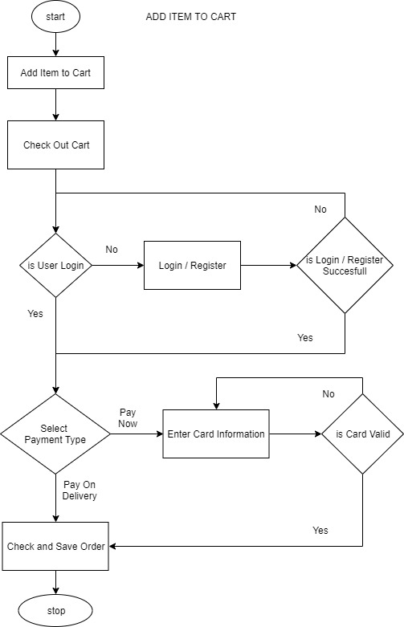

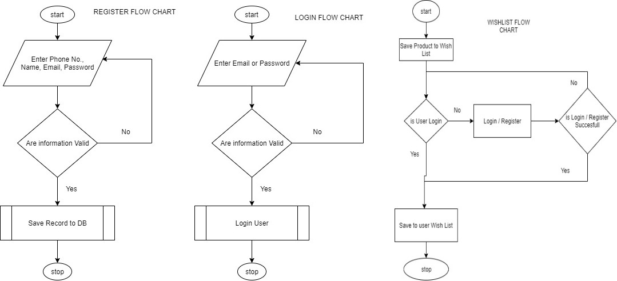

Figure 4.1: Flowchart of the Web App.

## 4.2 Use Case Diagram

The Use case diagram is illustrated in Figure 3.2 below it displays the diagrammatic representation of the user with the system. It enables the user to view the various activities that can be performed. The different users’ that have access to the Pharmacy E-Commerce web app can perform any of the listed operations.

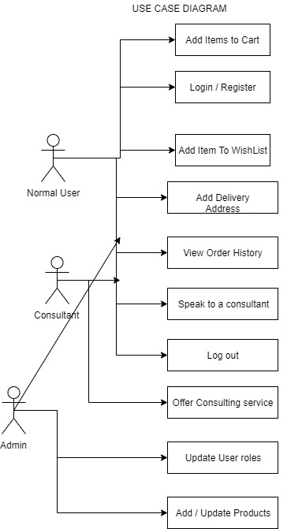

**Figure 4.2: Use case Diagram**

## 4.3 Block Diagram

The block diagram in Figure 3.3 below illustrates the design of the system. The user is provided access to the pharmacy e-commerce web app.

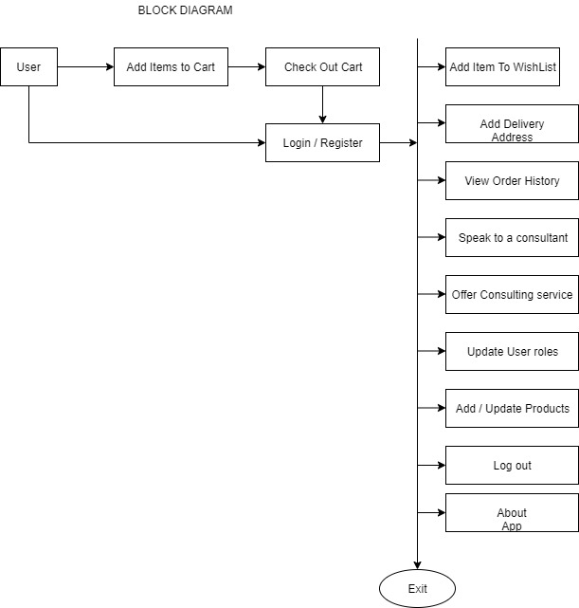

**Figure 4.3: System Block Diagram**

## 4.4 Sequence Diagram

The sequence diagram shows the interaction between objects in a sequential order that those interactions occur. The Sequence diagrams also demonstrate the behavior of objects in a use case by describing the objects and the messages they pass. The sequence diagram depicts interaction between objects in orders in which these interactions take place.

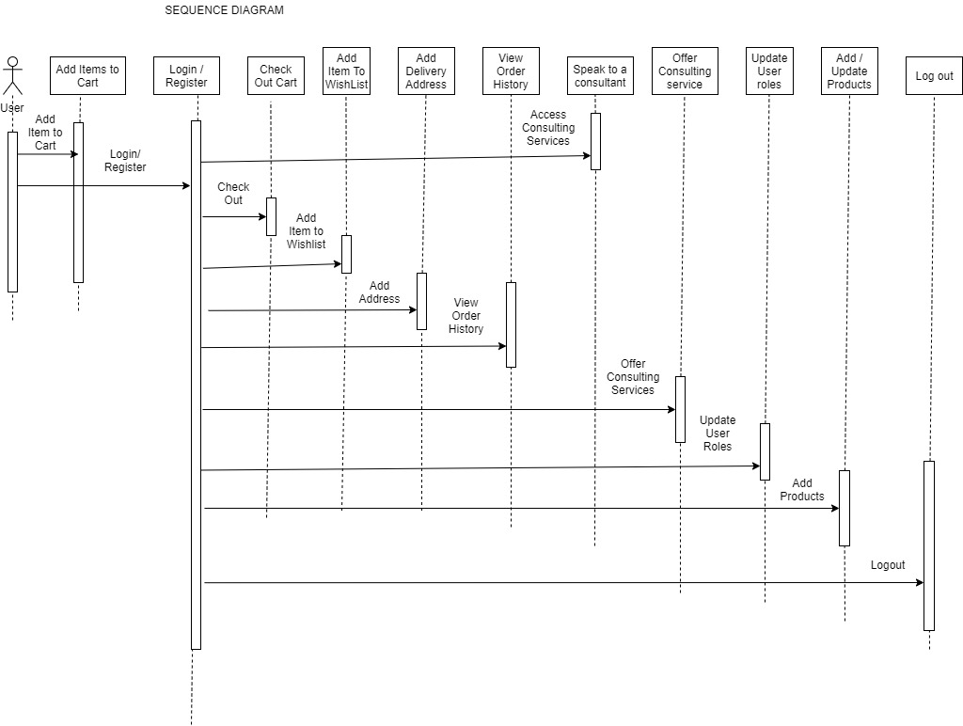

**Figure 4.4: The Sequence Diagram**

## 4.5 Architectural Context Diagram (ACD)

The ACD is used to model the manner in which software interacts with entities external to its boundaries. It shows the external entities that interact with the system, the systems that interact with the system, and systems that use and are used by the target system.

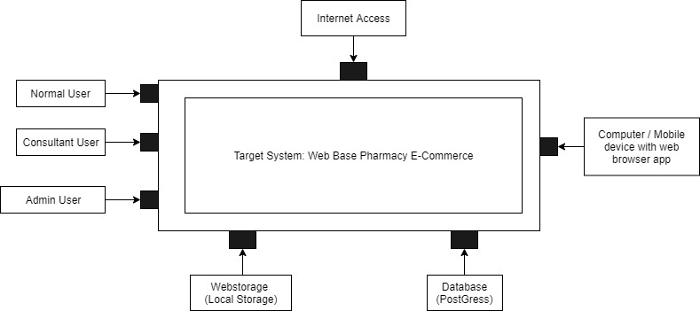

**Figure 4.5: Architectural Context Diagram (ACD) of the system**

## 4.6 System Architecture

A system architecture is the conceptual model that defines the structure, behavior, and more views of a system, An Architecture description is a formal description and representation of a system, organized in a way that supports reasoning about the structures and behaviors of the system by utilizing system architecture diagram to show the relationship between the different components. usually, they are created for systems which include hardware and software and these are represented in a diagram to show the interaction between them.

Below is the SAD of the proposed Pharmacy E-Commerce web App.

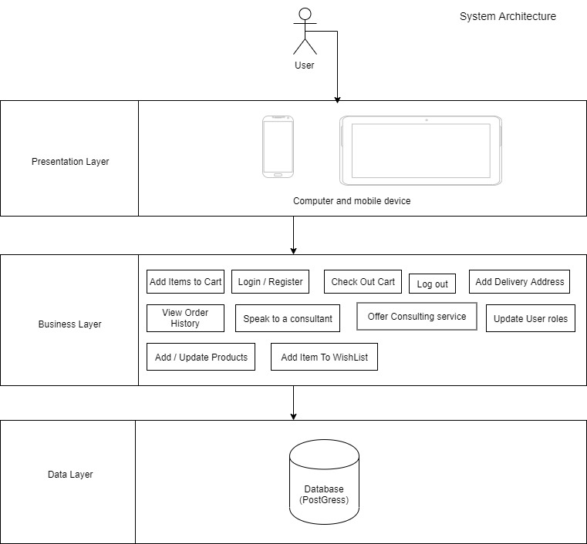

**Figure 4.6: System Architecture Diagram (SAD) of the system**

## 4.7 Entity Relationship Diagram

We have critically analyzed the nature of data required to build this system and we have structure the database to fit into our Architecture with so much emphasis on data normalization, integrity, retrieval and processing.

We have four entities(tables) in our database which are fully related to each other using database relationship.

We have use E-R Diagram to illustrate the relationship among the entities (table) in our database.

An entity-relationship diagram (ERD) is a data modeling technique that graphically illustrates an information system's entities and the relationships between those entities. An ERD is a conceptual and representational model of data used to represent the entity framework infrastructure.

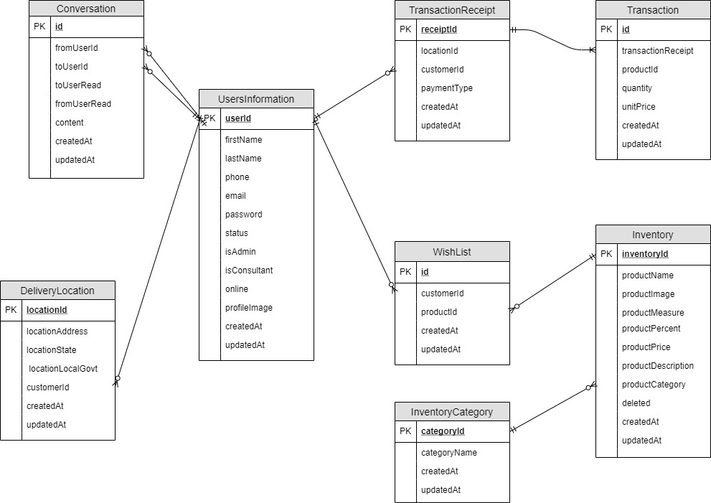

**Figure 4.7: Entity Relationship Diagram (ERD) of the system**

## 4.8 Wireframe Design

Wireframe is a blank template that allows creation of an app basic content layout, including interfaces and navigation, and how they work together.

Below is the wireframe design of the proposed system.

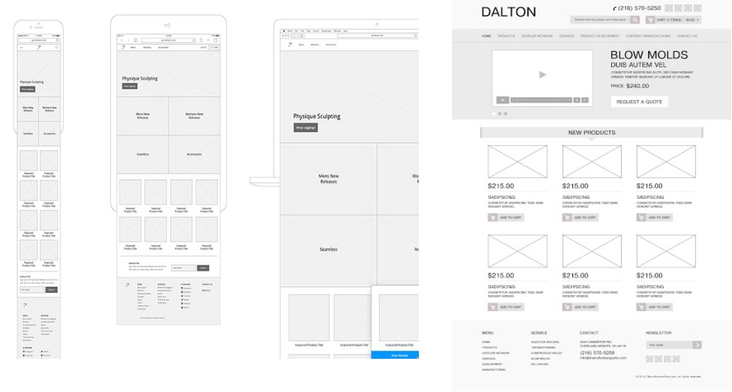

**Figure 4.8: Wireframe Diagram (ERD) of the system**

# Chapter Five: Implementation

## 5.1 Source code

const {Sequelize,Op, QueryTypes} = require('sequelize');

const { Validator } = require('node-input-validator')

const db = require('../../models');

const argon2 = require('argon2')

const { v4: uuidv4 } = require('uuid');

const jwt = require('jsonwebtoken');

// multipleStatements: true -> set this in config file if you want to run mutiple queries

const {users, products, categories} = require('./mockups')

const {UsersInformation,Conversation, InventoryCategory,WishList,Inventory,TransactionReceipt,Transaction,DeliveryLocation} = require('../../models/index');

let generateToken = (email,userId) =>{

return jwt.sign({

emailAddress:email,

userId:userId

},

process.env.MY_HASH_SECRET);

}

var cloudinary = require('cloudinary').v2;

cloudinary.config = ({

cloud_name:process.env.CLOUDINARY_CLOUD_NAME,

api_key:process.env.CLOUDINARY_API_KEY,

api_secret:process.env.CLOUDINARY_API_SECRET

})

exports.add_new_user = async (req,res,next)=>{

try {

const v = new Validator(req.body, {

firstName: "required|string|minLength:1",

lastName: "required|string|minLength:1",

email: "required|email",

password: "required|string",

phone: "required|phoneNumber",

isAdmin: "required|boolean",

isConsultant: "required|boolean"

})

const matched = await v.check()

if(!matched){

return res.status(412).json({

message:'Invalid Data Input'

});

}else{

let hashVerificationCode = await argon2.hash(req.body.password,process.env.MY_ARGON_SALT)

let userId = uuidv4();

let productUrl = null

if(req.files?.userImage){

let fileUpload = await cloudinary.uploader.upload(

req.files.userImage.tempFilePath,

{

folder: "pharmacy-products/"

})

productUrl = fileUpload.secure_url

}

//create new user

let userInformation = await UsersInformation.create(

{

firstName : req.body.firstName.trim(),

profileImage : productUrl,

lastName : req.body.lastName.trim(),

email : req.body.email.trim(),

phone : req.body.phone.trim(),

userId:userId,

password : hashVerificationCode,

isConsultant : req.body.isConsultant,

isAdmin : req.body.isAdmin

});

const tokenValue = generateToken(userInformation.email,userInformation.userId)

return res.status(200).json({

message:'Created',

userInformation,tokenValue

});

}

} catch (error) {

return res.status(500).json({

message:'Fail',

error:error

});

}

}

exports.add_new_customer = async (req,res,next)=>{

try {

const v = new Validator(req.body, {

firstName: "required|string|minLength:1",

lastName: "required|string|minLength:1",

email: "required|email",

password: "required|string",

phone: "required|phoneNumber"

})

const matched = await v.check()

// console.log(v.errors)

// console.log(req.body)

if(matched){

let hashVerificationCode = await argon2.hash(req.body.password,process.env.MY_ARGON_SALT)

let userId = uuidv4();

//create new user

let userInformation = await UsersInformation.create(

{

firstName : req.body.firstName.trim(),

lastName : req.body.lastName.trim(),

email : req.body.email.trim(),

phone : req.body.phone.trim(),

userId:userId,

password : hashVerificationCode

});

const tokenValue = generateToken(userInformation.email,userInformation.userId)

return res.status(200).json({

message:'Created',

userInformation, tokenValue

});

}

return res.status(422).json({

message:'Fail'

});

} catch (error) {

return res.status(500).json({

message:'Fail',

error:error

});

}

}

**More on my Github Repo**

RestFul API:

React APP:

# Chapter 6: Testing

## 6.1 Software Testing

Software testing is a process of executing a program or application with the intent of finding the software bugs. Is a method to check whether the actual software product matches expected requirements and to ensure that software product is[defect](https://www.guru99.com/defect-management-process.html)free. This involves execution of software/system components using manual or automated tools to evaluate one or more properties of interest. The purpose of software testing is to identify errors, gaps or missing requirements in contrast to actual requirements.

It can also be stated as the process of validating and verifying that a software program or application or product: Meets the business and technical requirements that guided its design and development.

## 6.2 Testing Plan

**We intend to use a black box testing technique by engaging users of the app to evaluate every functionality of the app including the functional and non-functional requirements. We plan to implement this test plan using Black box testing method which is mostly use in software testing.**

**Black Box Testing,** also known as Behavioral Testing, is a software testing method in which the internal structure/ design/ implementation of the item being tested is not known to the tester. Thereby making it easier to evaluate both functional or non-functional requirement of a software.

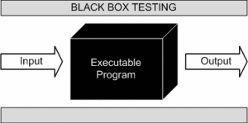

This method is named so because the software program, in the eyes of the tester, is like a black box; inside which one cannot see. This method attempts to find errors in the following categories:

* Incorrect or missing functions
* Interface errors
* Errors in data structures or external database access
* Behavior or performance errors
* Initialization and termination errors.
* Functional requirements.

**Why Is Black Box Testing Chosen?**

* Tests are done from a user’s point of view and will help in exposing discrepancies in the specifications.
* Tester need not know programming languages or how the software has been implemented.
* Tests can be conducted by a body independent from the developers, allowing for an objective perspective and the avoidance of developer-bias.
* Test cases can be designed as soon as the specifications are complete

## 6.3 Important Checklist

We are deploying a black box testing technique to check the overall functional and non-functional requirements of the software, but thou we have set aside some functionalities as the main target or focus of the test.

The important checklist on this test is listed below:

1. Ability to register and login.
2. Ability to add items to Wishlist
3. Ability to add items to cart and checkout item.
4. Ability to use the different payment options.
5. Ability to consult or chat with professional pharmacist online.
6. Ability to manage user information.
7. Ability to manage inventory (creating and updating)
8. Ability to manage users and user roles.
9. Ability to manage existing orders.
10. Easy navigation and access to all available features on the app.
11. User Experience.
12. Data retrieval in respect to load time.
13. The reliability of the chatting program
14. Data validation.

## 6.4 Error and Success Functionality test

Test result was reviewed and critically analyzed to achieve the testing analysis of the software application.

Below is the test result presented in a tabular form.

|  |  |  |  |
| --- | --- | --- | --- |
| **SNo** | **Test Item** | **Test Method** | **Test Result** |
| 1 | Access Control Ability | Unauthorized user access to the system. | Interception Successful |
| Unauthorized access to other user information. |
| Unauthorized access to application data. |
| 2 | Functional logic requirement | User Registration | Test results are according with the set requirements. |
| User Login |
| Adding items to Cart |
| Checking out cart |
| Adding item to Wishlist |
| Users and user role Management |
| Managing user Information (Updating profile) |
| Navigating between the apps |
| Managing the inventory (adding or updating products) |
| Managing previous orders |
| Chatting Live with consultants |
| Login out |
| 3 | Non-Functional logic requirement | User Experience | Test results are according with the set requirements. |
| Content Navigation |
| Enforcement of login before accessing the app protected resource |
| User input validation |
| Loading time |

# Chapter Seven: Demonstration

## 7.1 Activity Flow Diagram

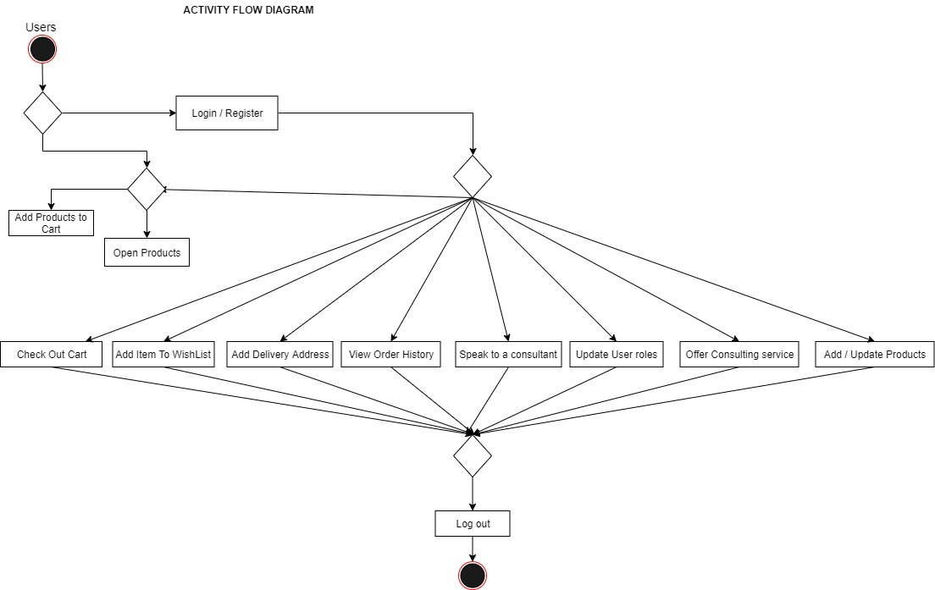

## 7.2 Activity Flow Screen

### 7.2.1 Home Screen

This is the web app home screen, this window provides users the ability to navigate through all the medicines available in the pharmaceutical stores, it also gives the user’s ability to filter through the products either by category or price range. Users can also add items to cart or wish list.

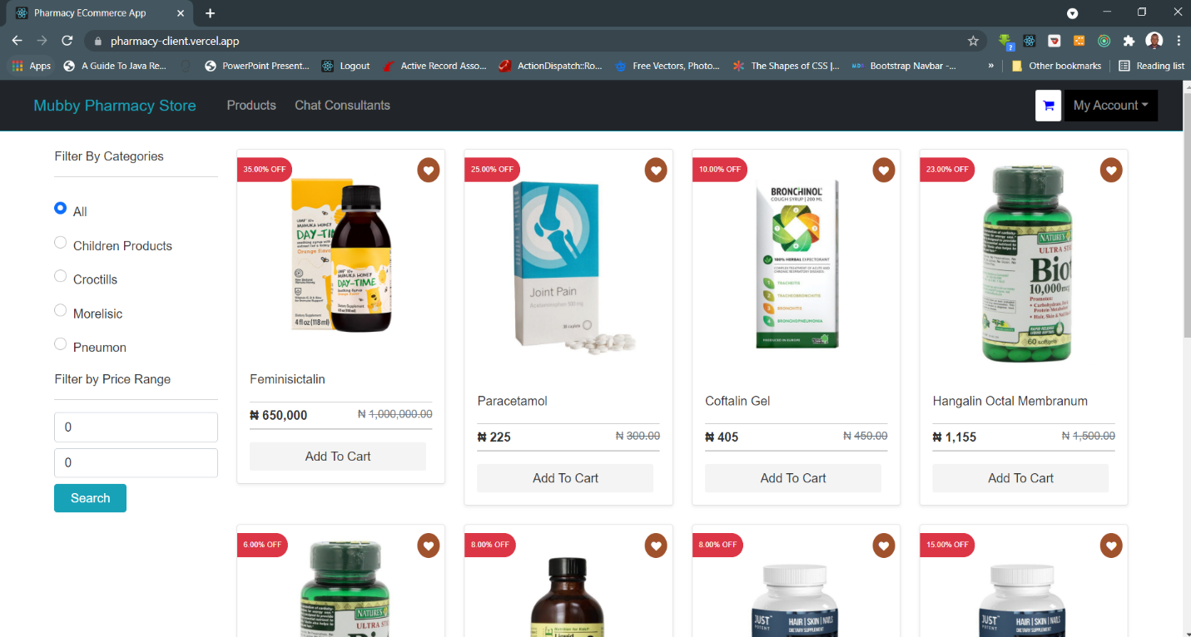

### 7.2.2 Login / Register Screen

This screen provides two functionalities, the login and the register screen. The login allow user to login into the system by providing their email address and password while the register form can be use by users to register their information for the first time by providing their name, phone, email and password.

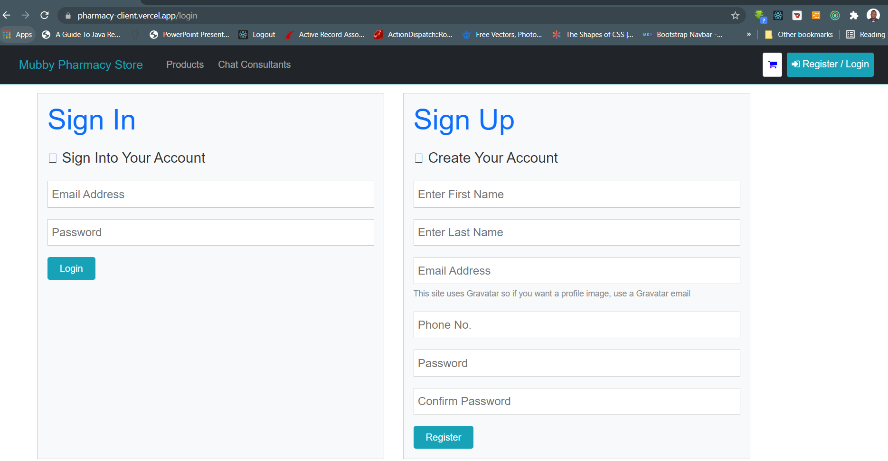

### 7.2.3 Cart Review Window

This screen provides the users with the complete review of items in their cart. With this screen the users will be able to add or remove item from their cart before the final check out.

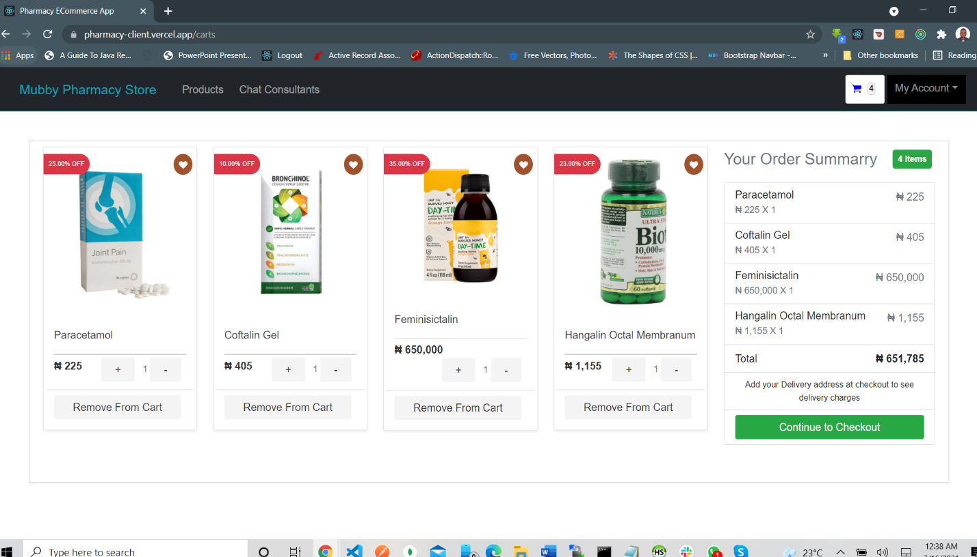

### 7.2.4 Check Out Screen

This screen provide user with a complete summary of the cart items and the grand total of every item in the cart. In this screen users will be able to select their payment method and add or change their delivery locations. If pay now is selected the screen will present a form for the user to input a credit card information for the check out. User can also modify the items in their cart from this list (by either removing the item from cart or adding it to the Wishlist).

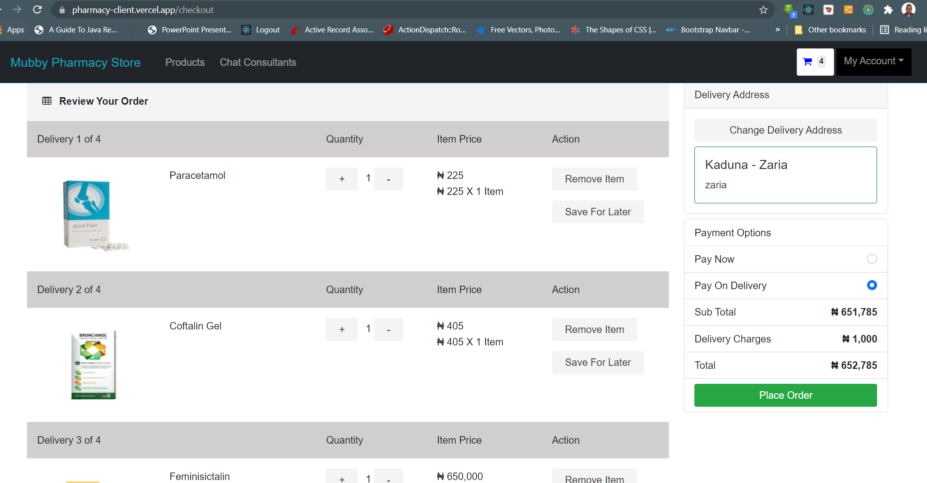

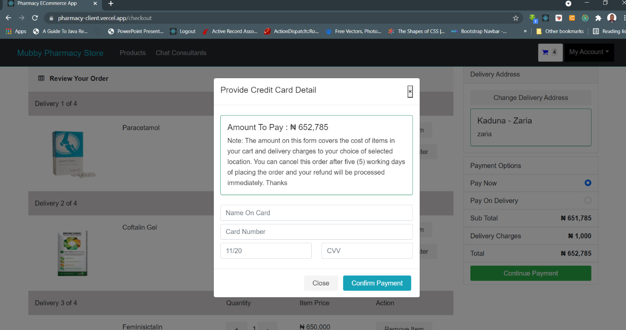

### 7.2.5 Wish List Cart

The Wish List window provide users the ability to manage items in their Wishlist. User can remove items from the Wishlist or add item on their Wishlist to cart.

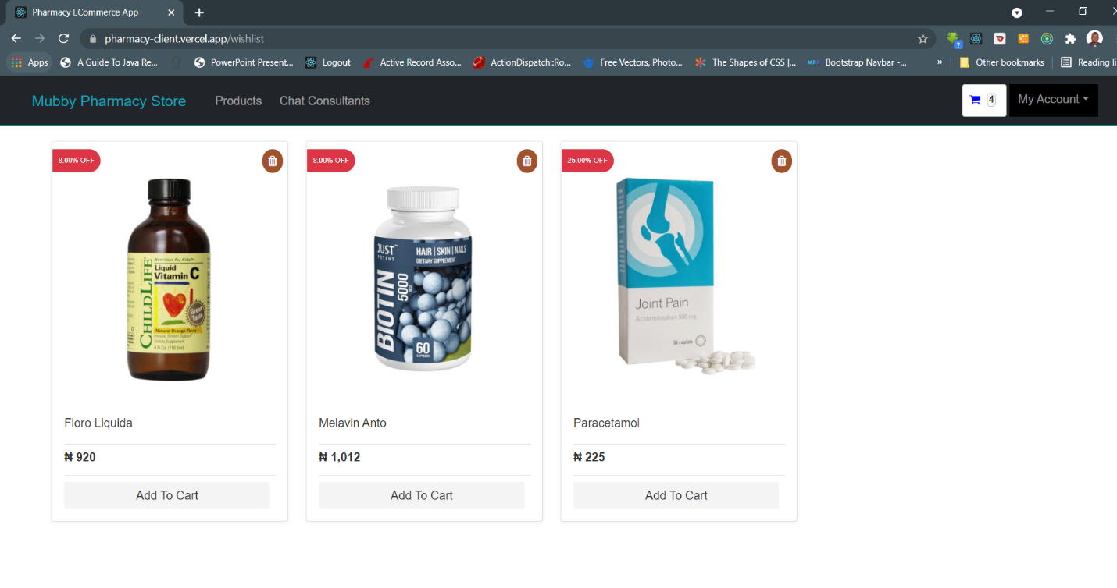

### 7.2.6 Product Preview Screen

This window provides users the complete details of a selected product and as well provide list of related products. Users can also add product to their cart or Wishlist from this screen.

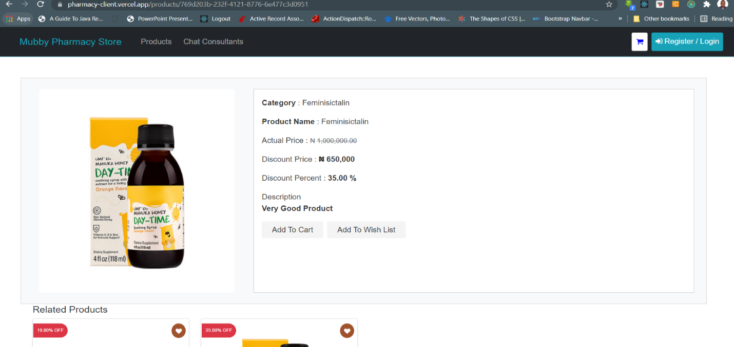

### 7.2.7 User Profile Dashboard

This window provides users with all the functionalities to manage their profile. User can update their profile information, change password and manage delivery address.

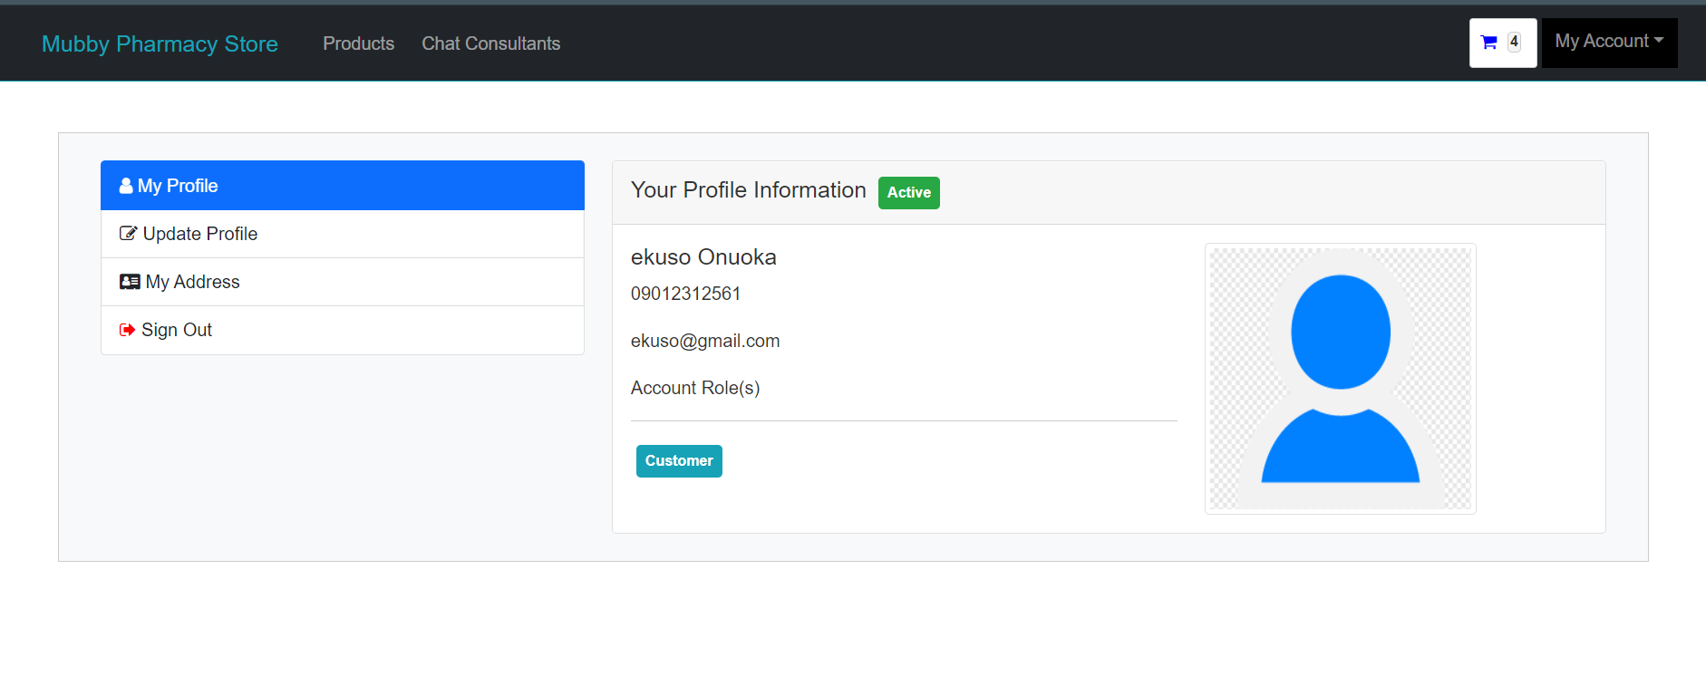

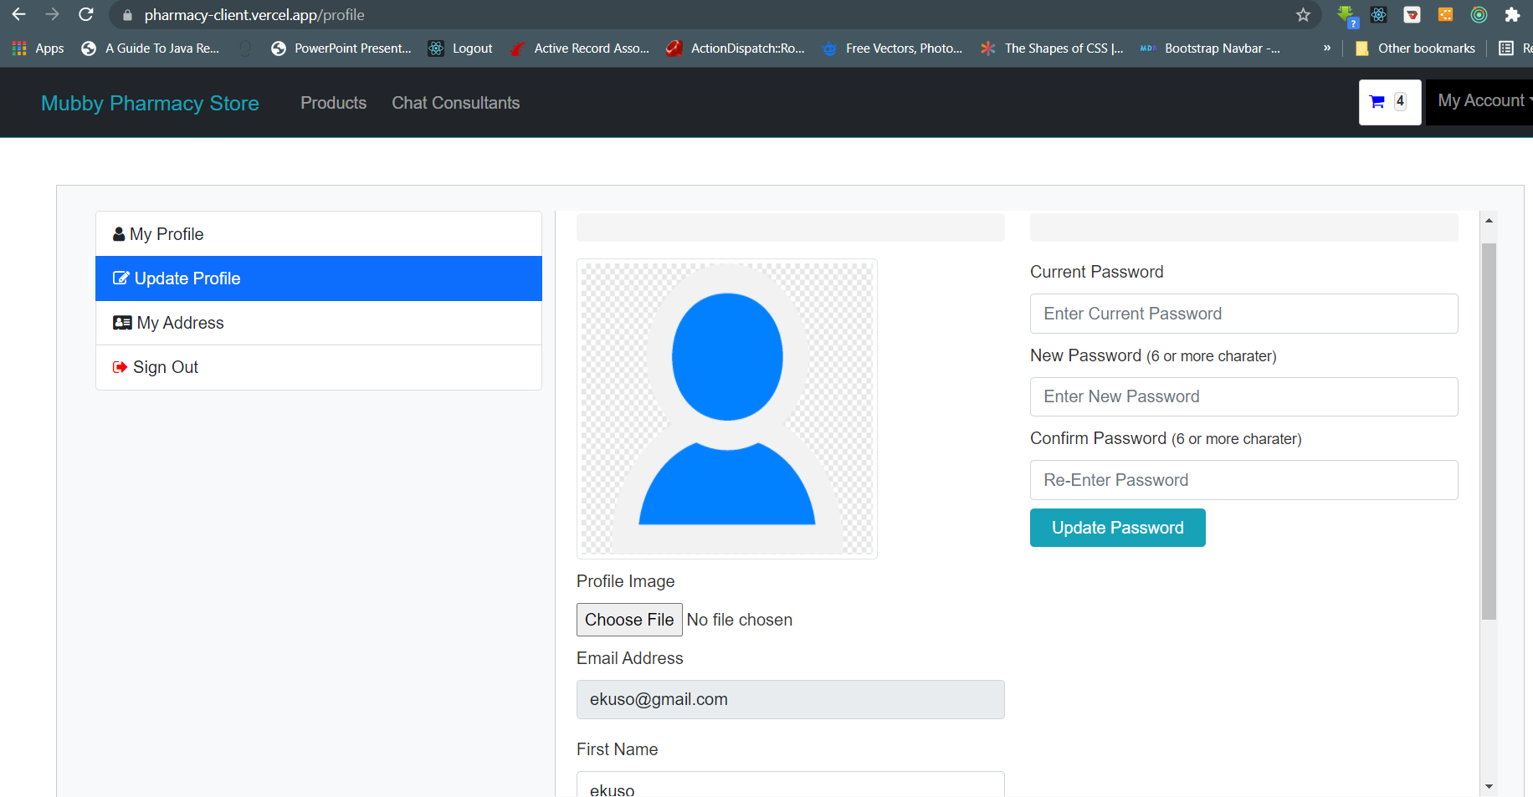

### 7.2.8 Order Management Window

This window provides users the history of all their previous orders on the platform.

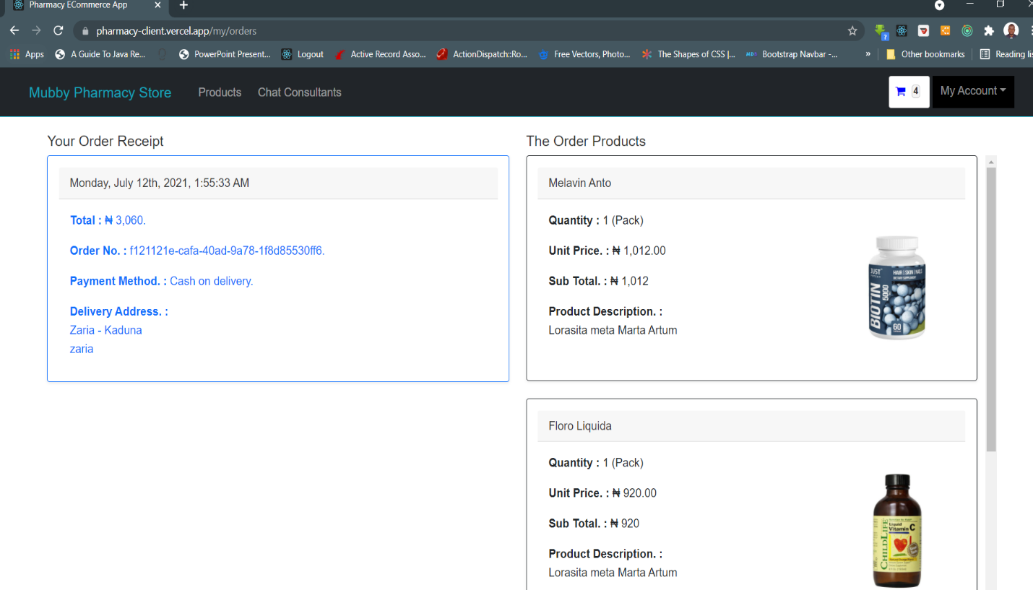

### 7.2.9 Admin Management Dashboard

This is the dashboard window for the system administrators to manage the content and resources of the system. The windows provide the administrators the ability to create / update product categories, products and change the roles of the system users.

7.2.9.1 Add / Update Category

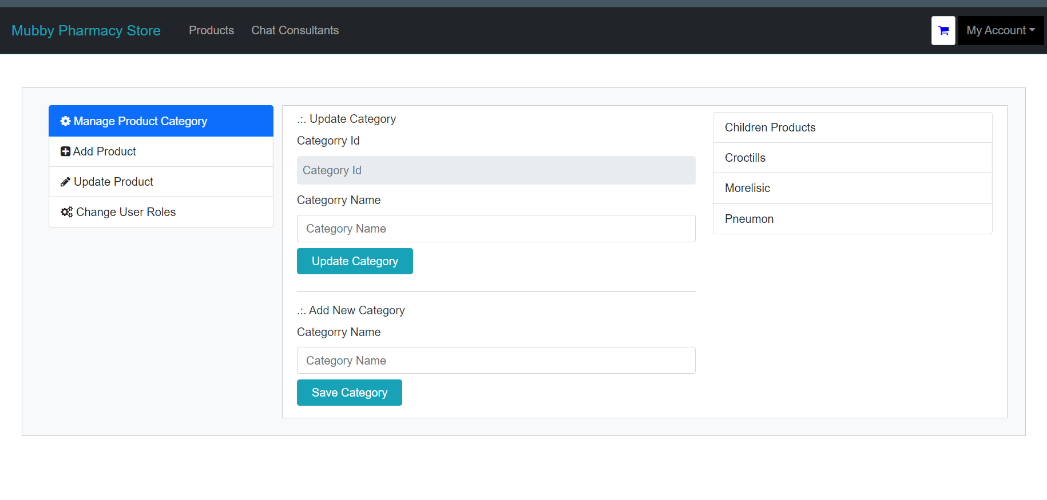

7.2.9.2 Add Product

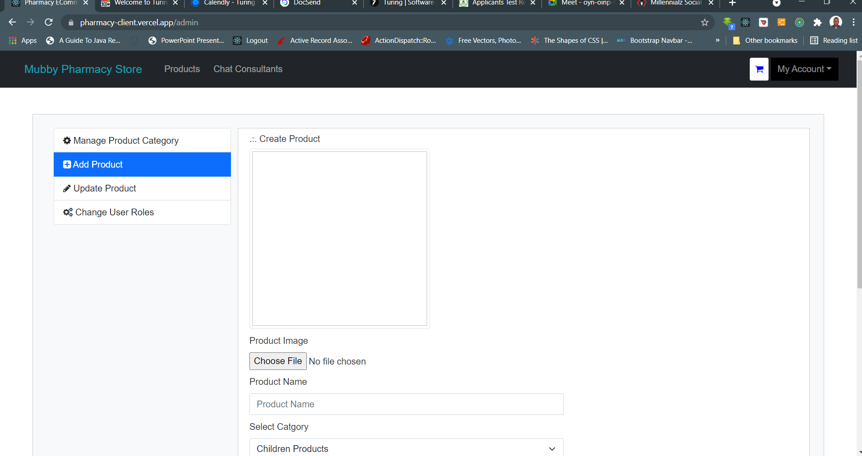

7.2.9.3 Update Products

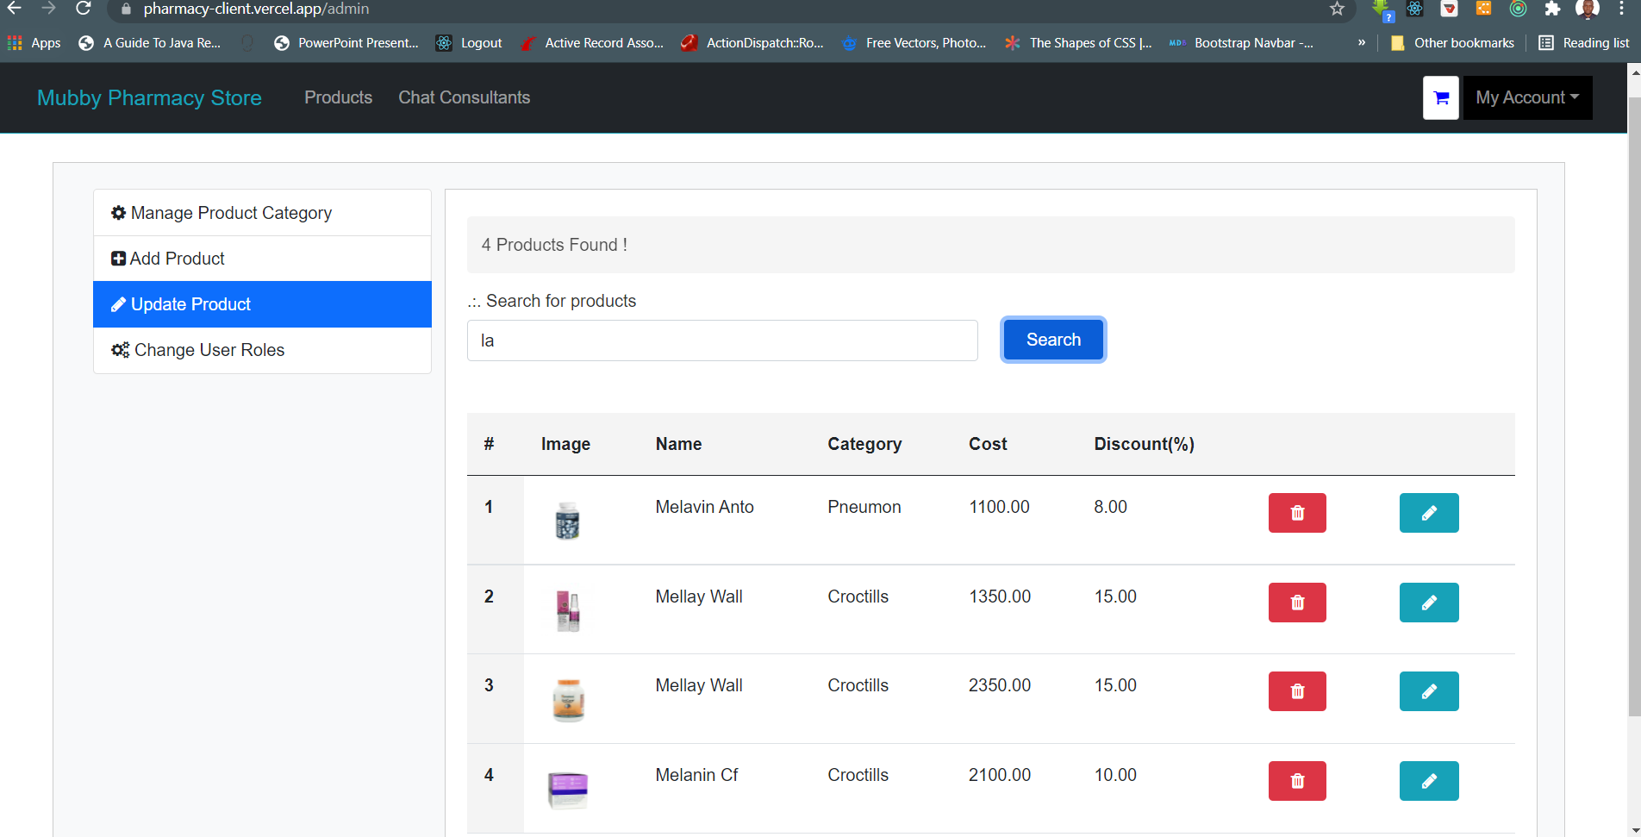

7.2.9.4 Modify User Roles

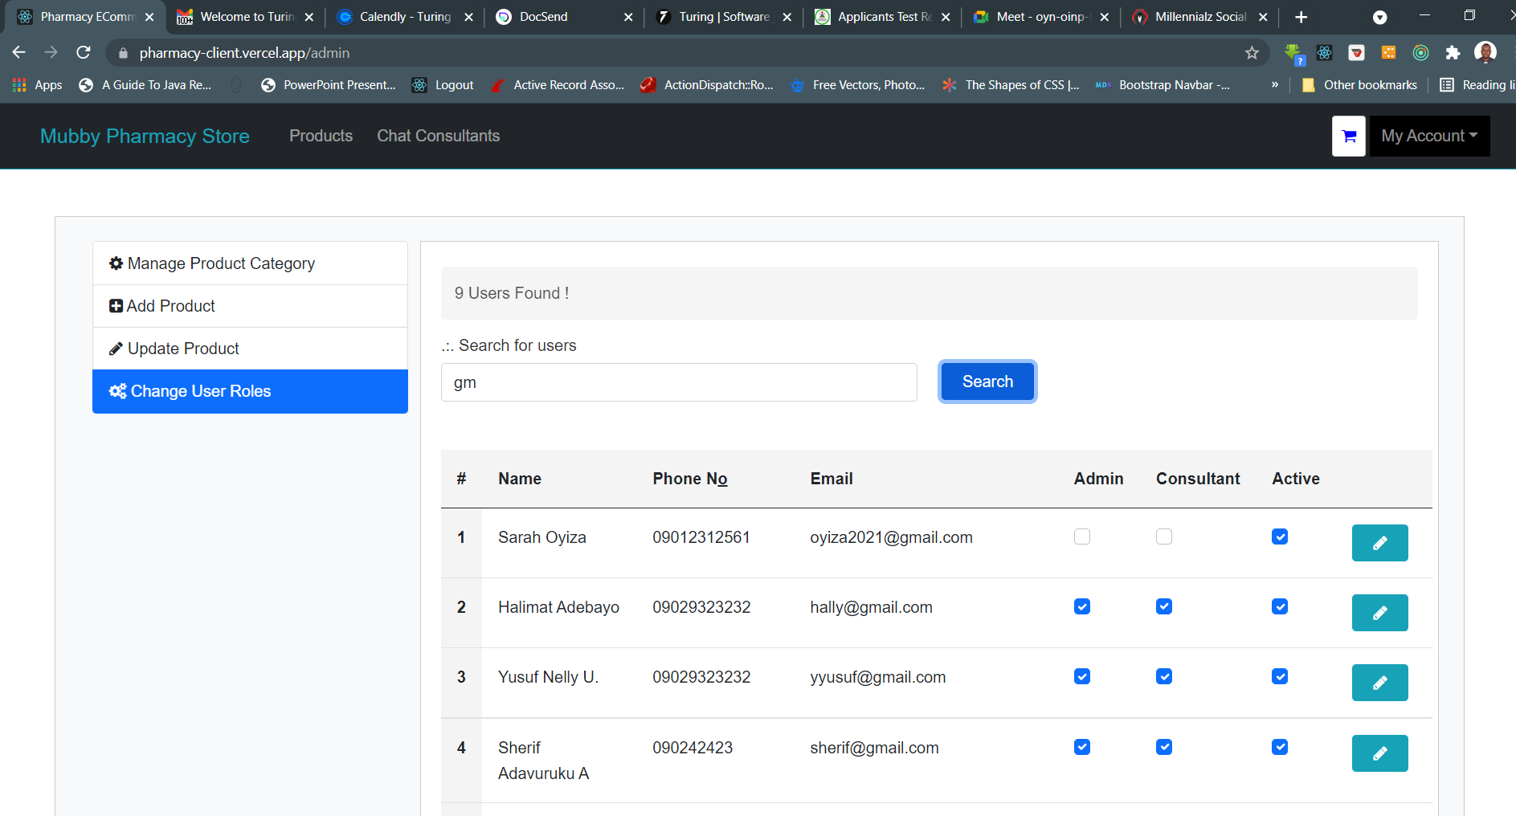

### 7.2.10 Consultation / Messenger Window

This screen provides the environment for users the ability to message and have a conversation with the registered professional consultants on the system. The users can send message to any of the consultants. Since is a real-time bidirectional messaging platform, the consultant can reply and have a real-time communication with the users.

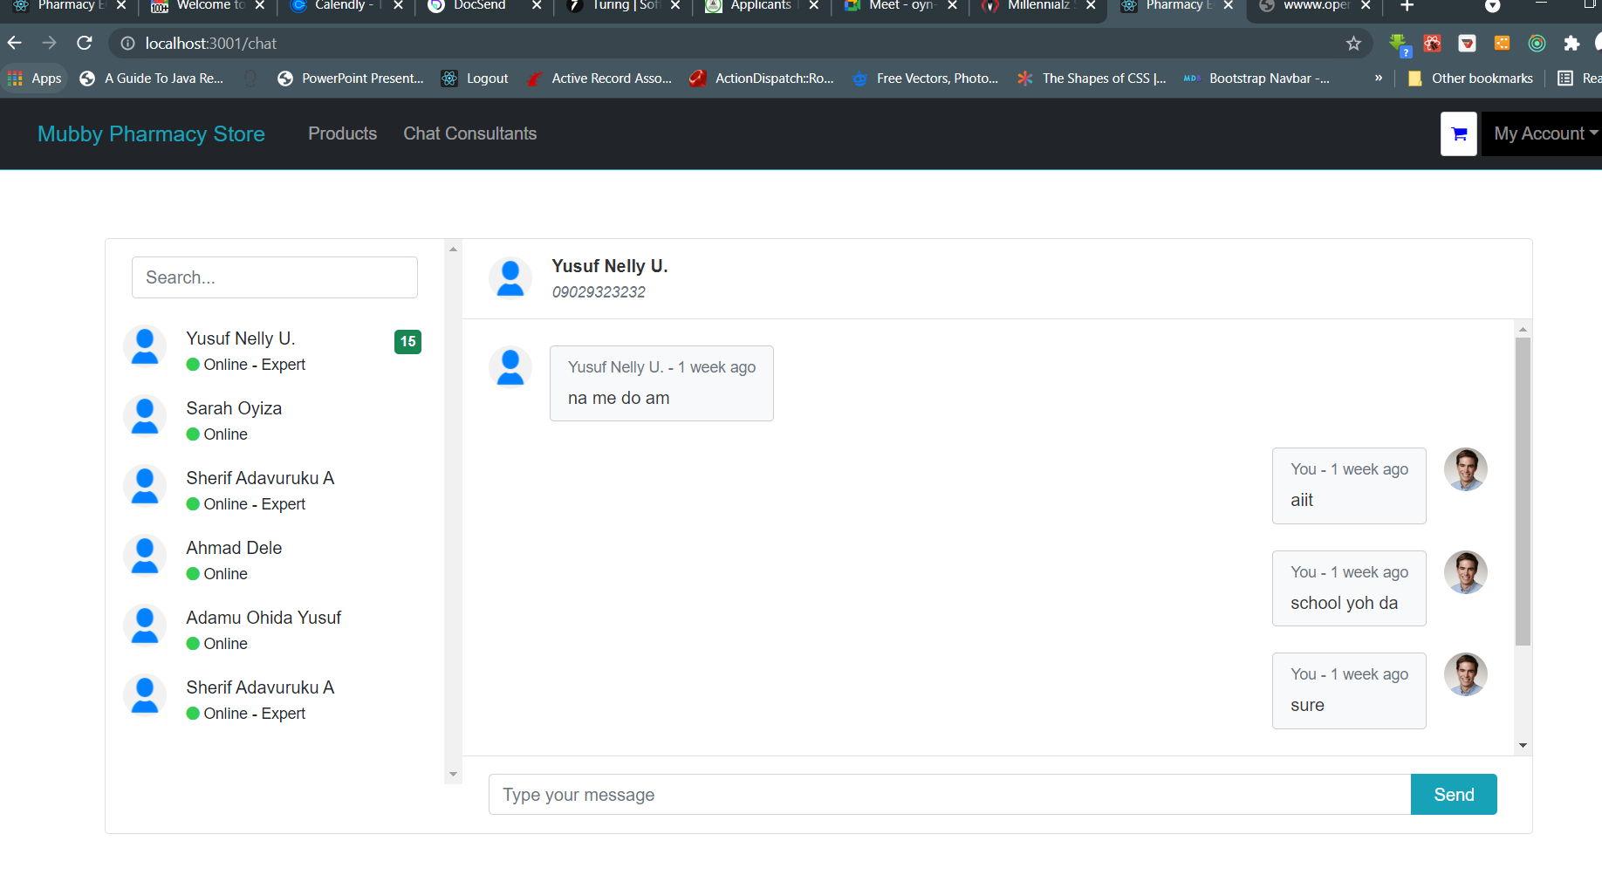

## 7.2.11 About APP

This screen provides detail information about the project

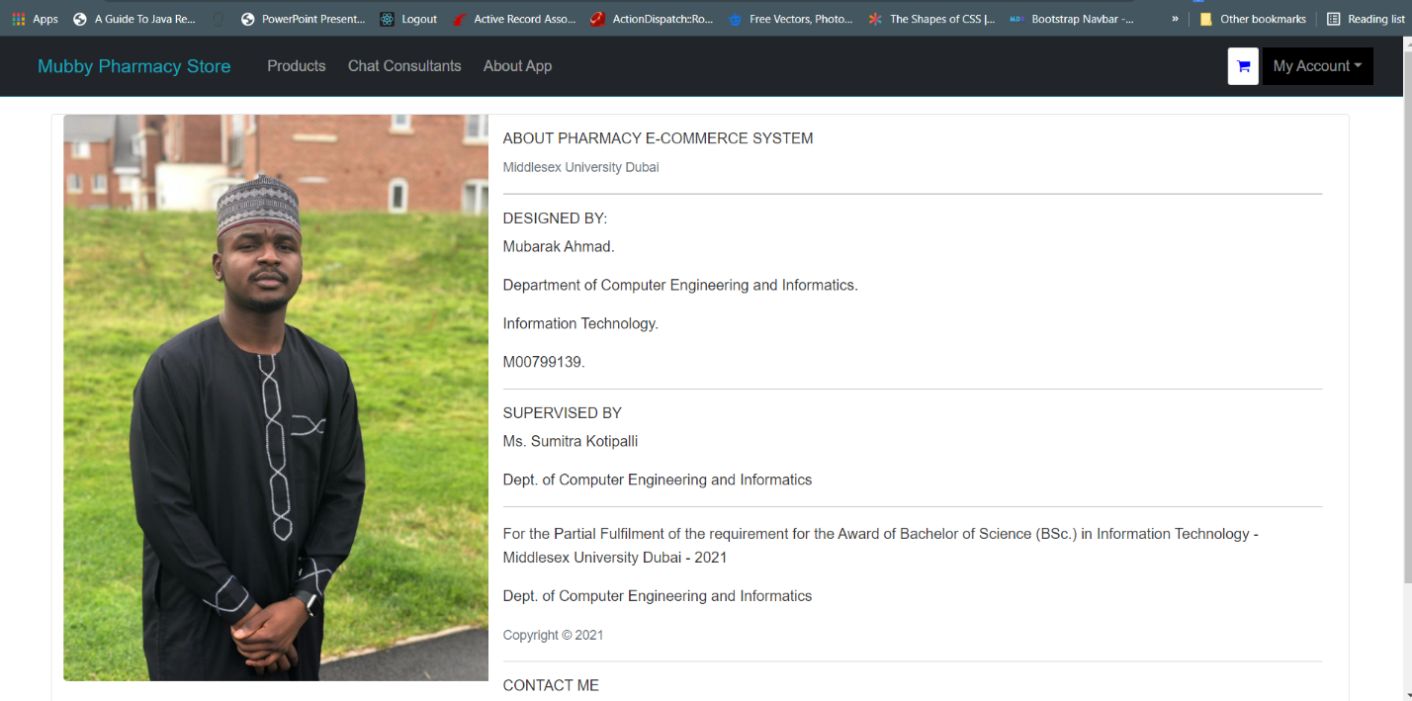

# Chapter Eight: Conclusion and Recommendation

## 8.1 Conclusion

The E-Commerce Pharmacy System (EPS) aims to reducing paper work & provide multiple facilities to user with less efforts in accessing the web app. With Pharmacy E-Commerce, waiting and standing in queues to receive medicine from the pharmacy will become thing from the past. Moreover, customer’s orders will have delivered to their homes or any place of their choice so as to save time, efforts and money of customer. In addition, the proposed system will make patient very comfortable to get the medicine easily and in short time.

The EPS users will be able to get medicines directly from pharmacies without troubling. The system will help to reduces the communicating time and offer fast services, the system also provides a platform for users to get real time consultation from professional pharmacist and thus reduce the risk of drug trafficking and self-medication.

The application will be design, implemented and run using JavaScript frameworks.

## 8.2 Recommendations

The new system is expected to present many features with positive effect to both users and pharmacist but then a lot can still be done to improve on the system.

This includes:

1. Any future development should work on expanding the app to include more sections of medical fields.
2. Future development should also improve the design of the web app to be new, attractive and consistent in colors and images, lines and satisfy customers.
3. One of the most important measures we will be working on in the future is to provide pharmacy products to various part of the country.
4. We will further promote more for the products in the pharmacy by do advertisements in the internet, newspapers, television, by SMS and social networking sites.
5. Among future plans is to work on the mobile version of the application on the phone to make it easier for users to browse the pharmacy.
6. Also, to provide room for improvement, there is a need to take feedback from the application, therefore provision should be made for a review.

# Chapter Nine: Appendix

## 9.1 Quick Start Guide

The developed pharmacy e-commerce app is a web-based application that is aimed at providing a new means of running pharmaceutical store and the interaction between users and professional pharmacist for consultations.

**Application Requirements**

The minimum requirements for running the apps are:

1. A computer or mobile phone device.
2. The mobile phone needs to have a functioning and effective internet connection.
3. Installation of a web browser application.
4. After the installation user can then visit the website @ https://pharmacy-client.vercel.app to register their information on the app by providing their name, email and password. After successful registration users can then login with their registered email and password after which they can then access the resources available in the app.
5. User can also use the search tool resource to search through all the medicine in stock.
6. Users can always log out of the app and login at any time and still have their setting all kept intact.

## 9.2 Test Case Result

Black box testing was carried on the user end of this software while unit testing and system design test is carried on the programming flow the new app.

Below is the result of the test:

|  |  |  |  |
| --- | --- | --- | --- |
| **SNo** | **Test Item** | **Test Method** | **Test Result** |
| 1 | Access Control Ability | Unauthorized user access to the system. | Interception Successful |
| Unauthorized access to other user information. |
| Unauthorized access to application data. |
| 2 | Functional logic requirement | User Registration | Test results are according with the set requirements. |
| User Login |
| Adding items to Cart |
| Checking out cart |
| Adding item to Wishlist |
| Users and user role Management |
| Managing user Information (Updating profile) |
| Navigating between the apps |
| Managing the inventory (adding or updating products) |
| Managing previous orders |
| Chatting Live with consultants |
| Login out |
| 3 | Non-Functional logic requirement | User Experience | Test results are according with the set requirements. |
| Content Navigation |
| Enforcement of login before accessing the app protected resource |
| User input validation |
| Loading time |

## 9.3 Project Meeting Logs

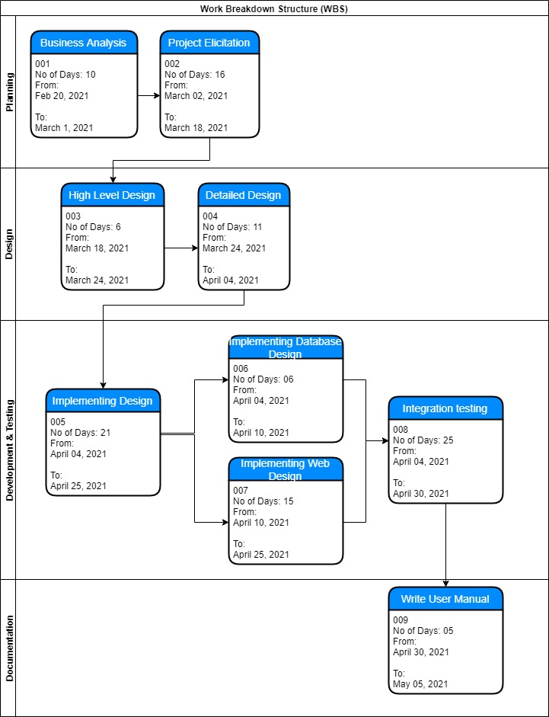

## 9.4 Timeline (Gantt chart)

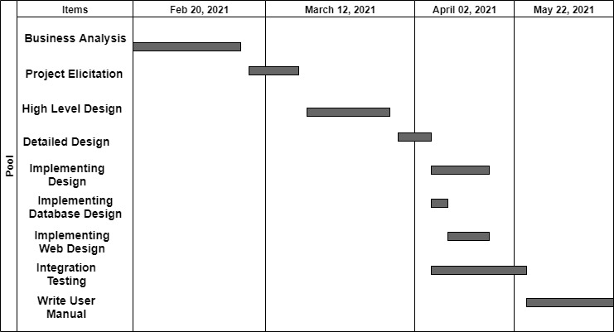

## References

1. fouda.com. (2013). fouda. Retrieved October 25, 2020, from <http://www.fouda.com/>
2. http://adamapharmacy.com/. (2016). adama pharmacy. Retrieved October 24, 2016, from <http://adamapharmacy.com/en/?sl=ar>
3. http://dowa.co/. (2016). Dowa Kuwait Online Pharmacy. Retrieved October 30, 2016, from <http://dowa.co/>
4. http://dowa.co/t-aboutus.aspx. (2016). About us. Retrieved November 17, 2016, from <http://dowa.co/t-aboutus.aspx>.
5. Peersman, G. (2014). Overview: Data Collection and Analysis Methods in Impact Evaluation, Methodological Briefs: Impact Evaluation 10, UNICEF Office of Research, Florence.
6. Martin, J. (1991). Rapid Application Development. Macmillan
7. Bray, J 2008, Consumer Behaviour Theory: Approaches and Models, viewed 20 February 2013,
8. Cottrill, K 2000, ‘E-health grows up’, Traffic World, vol. 263, iss. 4, p. 22, viewed 16 February 2013, EBSCOhost, Business Source Premier
9. Dudley, JW 2012 'Can e-commerce in Healthcare Succeed? Developments in Mail Order and Internet Pharmacy in Europe', viewed 02 March 2013, <http://www.jamesdudley.co.uk/downloads/other/new-developments-june2012.pdf>
10. Farrell, C & Fearon, G 2005, 'Prescription drug exports to the USA: An analysis of the online communication strategies of Canadian e-pharmacies', Journal of Medical Marketing, vol. 5, iss. 4, pp. 331-341, viewed 16 February 2013, EBSCOhost, Business Source Premier
11. 'Global ePharmacies Market' 2011, PRWeb, viewed 23 February 2013, <http://www.prweb.com/releases/epharmacies_internet/electronic_pharmacies/p web8525686.htm
12. Lane, MS & Koronios, A 2001, 'e-Pharmacy (www.epharmacy.com.au): A Successful Online Pharmacy in Australia', Department of Information Systems, Faculty of Business and Commerce, University of Southern Queensland, Australia, viewed on 02 March 2013 <https://domino.fov.unimb.si/proceedings.nsf/0/7bb173d9876002c4c1256e9f003 e/$file/45_lane.pdf